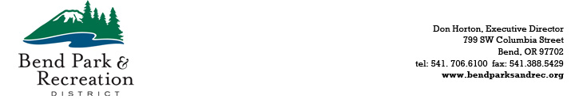

**April 9, 2025**

**PUBLIC NOTICE**

A quorum of the Park and Recreation District Board of Directors will meet at the district office, located at 799 SW Columbia Street, Bend, OR, at 9:00 a.m. on April 18, 2025, to participate in the annual budget preparation tour of parks and facilities. This is an informational meeting only; no decisions will be made.

For additional information, please contact: Sheila Reed at [sheilar@bendparksandrec.org](mailto:sheilar@bendparksandrec.org) or 541-706-6151.

* * * * * * * * * * * *